Summerhall Artist Development Programme

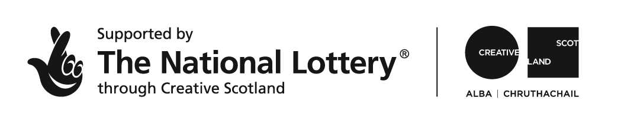

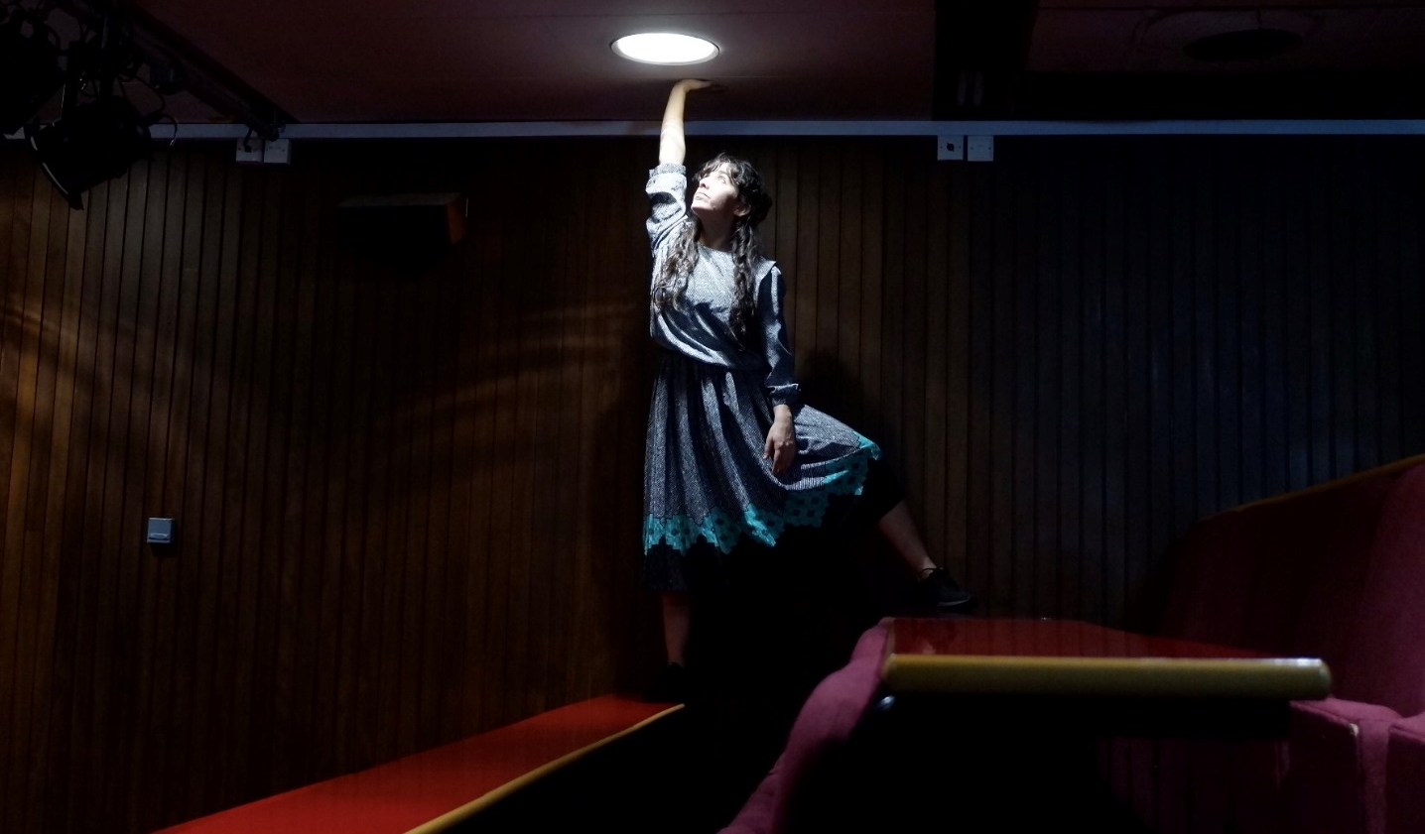

Summerhall is delighted to announce that we have been awarded funding from Creative Scotland for a programme of artist development initiatives. The programme comprises: two Labs, offering artists time, space and money to develop new work; two Scratch nights, offering artists the chance to try out an idea in front of an audience; four Space development weeks, offering artists in-kind space to develop new work; a Nothing Ever Happens Here… associate scheme for emerging bands and musicians; a residency for a visual artist and two Dissection songwriting workshops. The Lab strand is also supported by BBC Arts.
We are now inviting proposals for the following strands:
Summerhall Lab Spring 2019
Summerhall Space Spring 2019
Summerhall Scratch Spring 2019
Nothing Ever Happens Here… Associate Scheme
THE DEADLINE FOR ALL THESE OPPORTUNITIES IS SUNDAY 23 DECEMBER 2018.
You can apply for as many opportunities as you wish; we will need a separate application for each one. Please read the below information carefully to decide which is right for you.

Summerhall Lab Spring 2019
25-29 March 2019
We are looking for a company or group of artists to undertake a supported mini-residency at Summerhall for 1 week to develop a new work.

What do I get?

- Free development space for one week (Monday 25 – Friday 29 March 2019) in the Old Lab at Summerhall.
- A budget of up to £3000 to pay yourself, your collaborators and for any materials or production costs for the week.
- A sharing of work in progress at the end of your development week, to which we will invite industry professionals, other artists, Summerhall staff and Summerhall residents.
- A facilitated conversation with the audience at the end of the sharing, and the opportunity to continue the conversation in the bar afterwards.
- Advice and support from Summerhall’s programming team and other departments where appropriate/requested.
- Technical support for the sharing.
- Basic video documentation of the sharing.

What can I do in the space?
Rehearse or develop work and then share it with an invited audience. The Old Lab is a studio space with no permanently installed sound or lx, so your project must work in a low-tech environment.

What do you want from me?
An acknowledgement of Summerhall’s help on your publicity material if the work moves forward to production. And it would be great if, during your week at Summerhall, you could share a few social media posts tracking your process and development.

Who can apply?
Any artists, company or group of artists basing their practice in Scotland whose work is a good fit with Summerhall, who have a suitable project, would benefit from the opportunity and who do not receive regular funding support. We particularly welcome applications from artists who are from backgrounds or communities which are currently under-represented in our programme and/or in the wider performance sector in Scotland. We particularly welcome applications from artists or companies based in Edinburgh. We are looking to support work which is at an early stage of development, not to ‘top up’ an existing project grant or to add value to a development process which is already under way.

How will you choose the successful applicants?

We’ll apply the following criteria:
- quality of your proposal and its creative vision,
- fit with Summerhall’s programming policy; which can briefly be summarised as work which has something to say about the world with a focus on artistic excellence and an interest in pushing the boundaries of its form,
- our sense of the viability of the project and your longer-term plans for it
- practical criteria: will your project work in our space?

How do I apply?

Please complete the google form at https://goo.gl/forms/ONtbp7juiTxjdms83 with the following information:

- Your name and your company name if applicable.
- Contact details: phone number, email, postal address.
- Please give a brief description of you and your work.
- Please give a brief description of the project you want to develop at Summerhall.
- Links to supporting material such as your website, video documentation, any reviews of past work.
- Please tell us how your project fits with Summerhall’s programming policy as defined above.
- How will the Summerhall Lab help you to develop this project?
- Please tell us how you plan to make the project (when it reaches production) accessible to d/Deaf and disabled audiences.
- What are your longer-term plans/dreams for this project?
- A link to a budget for your project – on Dropbox/WeTransfer/Google Docs or similar (please remember to pay yourself and anyone you are working with!)

If you need to submit your application in another format for access reasons please contact programme@summerhall.co.uk

When’s the deadline?
The deadline for proposals is 5pm on Sunday 23 December 2018. If you have any questions about the application process, please be sure to ask them before Friday 21 December, as we won’t be available over the weekend. We will let you know whether or not your application has been successful by Friday 11 January 2019.

Will there be another opportunity to apply?
Yes! There will be a second round of Summerhall Lab, Summerhall Space and Summerhall Scratch in Autumn 2019.

Any questions?
Email us at programme@summerhall.co.uk

Good luck!
We look forward to hearing from you.

Summerhall Space Spring 2019

Summerhall Space offers artists in-kind space to develop new work. We’re offering two Space development weeks in Spring 2019.

What do I get?
Free rehearsal or development space for one week (Monday – Saturday 10am-6pm) in a lecture theatre space at Summerhall.

Which spaces are available?
One of the Cairns Lecture Theatre, the Red Lecture Theatre, the Anatomy Lecture Theatre or the Demonstration Room. The spaces are available with working lights and ‘as seen’.

Which dates are available?
There will be two weeks for two separate groups of artists, to be scheduled sometime before the end of April 2019. Rather than us picking a week in a specific space, we’d like to work with the successful artists to find the best space and dates for them, while also taking account of existing bookings in any of the rooms.

Do I get paid?
No, this is purely an offer of free space. The Lab and Scratch opportunities are both paid.

What can I do in the space?
Rehearse or develop work. Public sharings are not necessarily included, but we’re happy to discuss this if it’s something you would find useful.

What do you want from me?
If the work moves forward to production, then an acknowledgement of Summerhall’s help on your publicity material. And it would be great if, during your week at Summerhall, you could share a few social media posts tracking your process and development. We will also ask you to send us some feedback at the end of the week.

Who can apply?
Any artists, company or group of artists basing their practice in Scotland who would benefit from a week’s free rehearsal space and who do not receive regular funding support. We particularly welcome applications from artists who:
- make work which is a good fit with Summerhall’s programming policy
- are from backgrounds or communities which are currently under-represented in our programme and/or in the wider performance sector in Scotland.

How will you choose the successful applicants?

We’ll apply the following criteria:
- quality of your proposal and its creative vision
- fit with Summerhall’s programming policy; which can briefly be summarised as work which has something to say about the world with a focus on artistic excellence and an interest in pushing the boundaries of its form
- practical criteria: do we have space available when you need it?

Artistic criteria will come first, but we will also need to consider practicalities like availability of space – if you can be flexible about dates and venue spaces that might help!

How do I apply?
Please complete the online form here.

https://goo.gl/forms/RrpoNORgN2hUNQLT2

There isn’t the facility to save and return to the form, so the questions are listed below.

Questions
Name
Company Name
Email
Phone number
Address

Preferred Venue Space
Preferred Dates

Please give a brief description of you and your work (200 words)

Please give a brief description of the project you want to develop at Summerhall (200 words)

Supporting material
(If you have any of these then please share them with us – but it’s not essential for your application)
Website/Video/ Reviews of past work

How will a week in a space at Summerhall help you to develop this project? (100 words)

What are your longer-term plans/dreams for this project? (100 words)

When’s the deadline?
The deadline for proposals is 5pm on Sunday 23 December 2018. If you have any questions about the application process, please be sure to ask them before Friday 21 December, as we won’t be available over the weekend. We will let you know whether or not your application has been successful by Friday 11 January 2019.

Will there be another opportunity to apply?
Yes! The Space strand is an ongoing part of Summerhall’s commitment to supporting artists year-round. There will also be a second round of Summerhall Lab and Summerhall Scratch in Autumn 2019, with further iterations of those strands dependent on funding.

Any questions?
Email us at programme@summerhall.co.uk

Good luck!
We look forward to hearing from you.

Summerhall Scratch Spring 2019
Thursday 14 February 2019

Summerhall Scratch is a chance to try out an idea in front of an audience, as part of a mixed bill of new work from different artforms, in a supportive and fun environment.

What do I get?
The opportunity to share a 15-20 minute piece of work in progress with an audience in the Anatomy Lecture Theatre at Summerhall, as part of a mixed bill of new work.

Which spaces are available?
The Anatomy Lecture Theatre

Which dates are available?
Thursday 14 February 2019

Do I get paid?
Each artist performing will be paid a fee of £120.

What do you want from me?
It would be great if you could help us to reach audiences by sharing the event with your own networks. And we’ll ask you to send us some feedback after the show.

Who can apply?
Any artists, company or group of artists basing their practice in Scotland who do not receive regular funding support and who have a suitable piece of work to show.
We are looking for work which is a good fit with Summerhall’s programming policy and which is at a stage of development where it would benefit from a scratch performance.
We particularly welcome applications from artists based in Edinburgh and from artists who are from backgrounds or communities which are currently under-represented in our programme and/or in the wider performance sector in Scotland.

How will you choose the successful applicants?

We’ll apply the following criteria:
- Quality of your proposed piece
- Fit with Summerhall’s programming policy; which can briefly be summarised as work which has something to say about the world with a focus on artistic excellence and an interest in pushing the boundaries of its form
- Stage of development of your proposed piece
- Practical criteria: will your piece work in the Anatomy Lecture Theatre, in the context of a Scratch night, and with limited technical infrastructure.

Artistic criteria will come first, but we will also need to consider practicalities!

How do I apply?
Please complete the online form here.
https://goo.gl/forms/grqc52Vtihgr1I0J3

There isn’t the facility to save and return to the form, so the questions are listed below.

When’s the deadline?
The deadline for proposals is 5pm on Sunday 23 December 2018. If you have any questions about the application process, please be sure to ask them before Friday 21 December, as we won’t be available over the weekend. We will let you know whether or not your application has been successful by Friday 11 January 2019.

Will there be another opportunity to apply?
Yes! There will be a second Summerhall Scratch Night in Autumn 2019, as well as a second round of Summerhall Lab and Summerhall Space.

Any questions?
Email us at programme@summerhall.co.uk

Good luck!
We look forward to hearing from you.

Questions
Name
Company Name
Email
Phone number
Address

How many people are in your show?

Please give a brief description of you and your work (200 words)

Please give a brief description of the project you want to share at Summerhall (200 words)
We’re looking here for a straightforward description of what you want to do and why. Marketing copy can come later if we select your project!

Please tell us about any technical requirements of your piece (200 words)

What do you hope to find out by sharing the project with an audience? How do you hope the Scratch performance will help you develop the project in the future? (200 words)

Supporting Material
Website/Video/Reviews of past work
If you have any of these then please share them with us – but it’s not essential for your application

What are your longer-term plans/dreams for this project? (100 words)

NOTHING EVER HAPPENS HERE… Associate Scheme
2019

Nothing Ever Happens Here…, is proud to announce its new Associate scheme, supported by Creative Scotland, as part of our ongoing efforts to involve and enhance Edinburgh’s live music community and provide a platform for emerging musicians to progress their careers.

What do I get?
As part of the Associate Scheme we will be offering three successful applicants our Red Lecture Theatre for up to 30 hours a year per artist as free rehearsal space (dependent on availability), free tickets to all of the Nothing Ever Happens Here… presents programme throughout the year, a slot to perform at Summerhall’s yearly “Southern Exposure” Festival in June and a dedicated showcase event in December featuring all three chosen artists.

Which dates are available?
This will happen on a rolling basis dependent on availability of the room throughout the year, but each artist will get up to 30 hours free use of our Red Lecture Theatre as a rehearsal space, broken up as they see fit. Rehearsing to record an album or to go on tour? We can book in a couple of days straight and leave the gear set up. Want to do a couple of hours a week to write? We can find a time to make that work. We’d like to work with the successful artists to find the best dates for them, while also taking account of existing bookings in the room.

Do I get paid?
For the Southern Exposure and December Showcase events, we will offer a fee dependent on the artists’ profile at the time. There’s no payment for the rehearsal time, this is purely an offer for free space to rehearse.

What can I do in the space?
Rehearse or develop work. Public sharings are not necessarily included, but we’re happy to discuss this if it’s something you would find useful.

What do you want from me?
If the work moves forward to production and recording, then an acknowledgement of Summerhall’s help on your publicity material. And it would be great if, during your time at Summerhall, you could share a few social media posts tracking your process and development.

Who can apply?
Any band or musician basing their practice in Scotland who would benefit from the opportunity and who do not receive regular funding support. We particularly welcome applications from artists who:
- make work which is a good fit with Summerhall’s programming policy
- are from backgrounds or communities which are currently under-represented in our programme and/or in the wider performance sector in Scotland.

How will you choose the successful applicants?
We’ll apply the following criteria:
- quality of your proposal and its creative vision
- fit with Summerhall’s programming policy; which can briefly be summarised as work which has something to say about the world with a focus on artistic excellence and an interest in pushing the boundaries of its form
- practical criteria: do we have space available when you need it?

Artistic criteria will come first, but we will also need to consider practicalities like availability of space – if you can be flexible about dates and venue spaces that might help!
How do I apply?
Please complete the online form here: https://goo.gl/forms/I2BdNCfoIvPbFRZh1 There isn’t the facility to save and return to the form, so the questions are listed below.

When’s the deadline?
The deadline for proposals is 5pm on Sunday 23 December 2018. If you have any questions about the application process, please be sure to ask them before Friday 21 December, as we won’t be available over the weekend. We will let you know whether or not your application has been successful by Friday 11 January 2019.

Any questions?
Email us at programme@summerhall.co.uk

Good luck!
We look forward to hearing from you.

Questions
Name
Company Contact Details
Phone number
Address

Preferred Dates or Rehearsal Schedule

Please give a brief description of you and your work (200 words)

Please give a brief description of the project you want to develop at Summerhall (200 words)

Supporting material
(If you have any of these then please share them with us – but it’s not essential for your application)
Soundcloud/Website/Video/ Reviews of past work

How will becoming a Nothing Ever Happens Here… Associate help you to develop this project? (100 words)

What are your longer-term plans/dreams for this project? (100 words)

Summerhall
1 Summerhall
Edinburgh
Scotland
EH91PL

programme@summerhall.co.uk
0131 560 1580

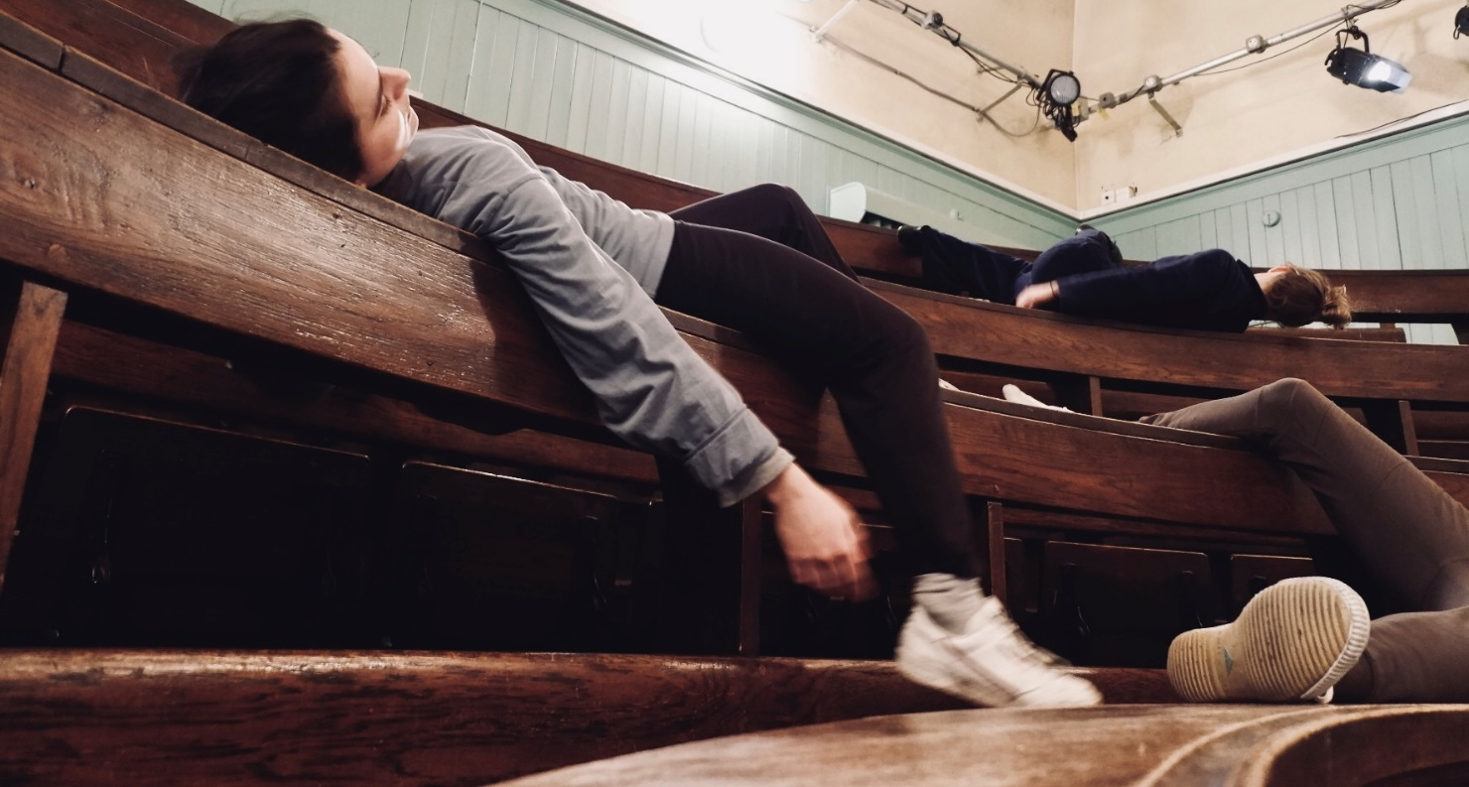
Summerhall Mgt Ltd
Registered office: 1 Summerhall, Edinburgh EH9 1PL
Registered in Scotland: no. SC411968
VAT Registration no: 125815812

